ANNA UNIVERSITY, CHENNAI 25

MODEL QUESTION PAPER

B.E. Aeronautical Engineering, , VI SEMESTER

AE344 - THEORY OF VIBRATIONS

TIME – 3 Hours MAXIMUM : 100 Marks

PART A (10 X 2 = 20 Marks)
ANSWER ALL QUESTIONS

1. Given a sinusoid signal with frequency equal to 2π rad/s and initial velocity equal to 5 units / sec, find x (t).

2. What must be the length of a simple pendulum for the period of oscillation to be equal to 1 second?

3. What is a viscous damper?

4. A system is described by the following differential equation:

d²X dX
- --------- + c -------- + 2000X = 0
dt² dt

Find the value of c if the system is critically damped.

5. Name the parameters that govern the natural frequency of longitudinal vibrations for a given bar.

6. With the example of a simple pendulum vibrating system, write a short note on the meaning of linearization.

7. List a few approximate methods that can be used to calculate the natural frequencies of a given system.

8. Explain the term AEROELASTICITY

9. Sketch COLLAR'S triangle and mention its implication.

10. Write a short note on Mass Balancing.

PART B - (5 x 16 = 80 marks)

11. (i) Define simple harmonie motion and give an illustrative
example of the same. 6

(ii) For the system shown in Figure 1 below, determine the natural
frequencies and eigen vectors. Given : M₁ = 2kg, M₂ = 4 kg,
K₁ = 40 N/m, K₂ = 100 N/m, K₃ = 200 N/m. 10
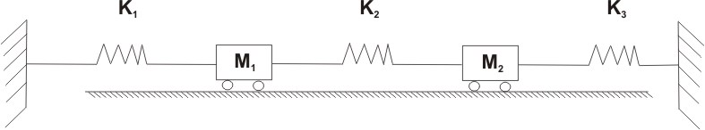

Figure 1

12 (a) The system shown in Figure 2 is given an excitation at a frequency w. The
absolute value of the response = 3.6mm. Given m = 0.05 kg , K = 45 N/m ,
and y (t) = 2 sin (wt) mm, determine w. 16
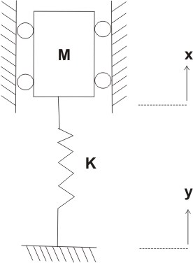

Figure 2

( OR )

12 (b) (j) Explain the meaning of RESONANT FREQUENCY. 6

(ii) For a SDOF spring - mass system oscillating in the vertical plane,
obtain the relationship between natural frequency and
static deflection. 8

(iii) Give an example of a MDOF System 2

13 (a) (i) Differentiate between principal coordinates and
generalized coordinates 6

(ii) State Hamilton`s Principle 4

(iii) Write notes on the Lagrangian equations and their application 6

( OR )

13 (b) Derive and obtain the governing differential equation for a uniform beam
undergoing free lateral vibrations. Treate the beam as a CONTINUOUS
system. 16

14 (a) (i) State the D`Alembert Principle 4

(ii) With an example, explain the orthogonality condition in
vibration theory 6

(iii) Name any one vibration measuring instrument and explain
now it functions. 6
( OR )

14 (b) The torsionally geared system shown in Figure 3 consists of 3 discs
with moments of inertia I₁ = 4600kg cm² , I₂ = 600kg cm² and
I₃ = 80kg cm² respectively. The gear ratios are n₂ = 2 and n₄ = 4
with respect to I₁. Find the natural frequencies of the system. 16

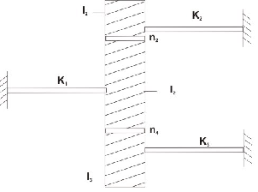

K₁ = 35 x 10⁶ Ncm / rad
K₂ = 15 x 10⁶ Ncm / rad
K₃ = 5 x 10⁶ Ncm / rad

Figure 3

15 (a) (i) Define the following: elastic axis, aerodynamic centre, flexural axis,
aileron reversal speed. 8

(ii) For the simple 2-D case, derive and obtain an expression for the wing
divergence speed. 8

( OR )

15 (b) An airfoil is undergoing contrained vertical translatory motion and
rotational motion in the same plane. Derive and obtain the governing
differential equations of motion for the airfoil. The springs
associated with the translation and rotational motions have spring
constants Kn and Ka respectively. 16

